Learning Objectives

LO1 – Mean/Floor/Dispersion as Concepts
1.1 Identify the average (mean) of a distribution
1.2 Identify the floor (lowest point of a distribution)
1.3 Identify the difference in inequality/dispersion of two distributions
(Taught content, pre-test as a covariate)

LO2 – Using Qualities of Distributions to Assess Benthamite and Rawlsian Approaches
2.1 Identify the Benthamite approach’s pros and cons
2.2 Identify the Rawlsian approach’s pros and cons
2.3 Given three distributions, identify which one a Benthamite rule would prefer and which one a Rawlsian rule would prefer.

LO3 – What Utility Is and How it Overcomes This
3.1 Identify that utility is the value of a 1-point gain in life satisfaction, and that it depends on where the person starts
3.2 Identify the Benthamite and Rawlsian approaches as two ends of this scale (e.g. given a scoring system, identify which end it sits nearer)
3.3 Identify that utility values come from the risks people would accept in hypothetical gambles

LO4 – Personal & Social Utility, and the Issue of Which to Choose
4.1 Identify personal utility (gambles about your own life) and social utility (the same gambles made for others, behind the veil of ignorance)
4.2 Identify that people choose more riskily for themselves than they would for others
4.3 Identify that social utility places more weight on the worst-off than personal utility does, and how that creates a policymaking dilemma
4.4 Apply personal and social logic to the same policy scenario and explain why they diverge
4.5 Identify the case for each: personal utility respects the choices people make for their own lives; social utility reflects what people endorse when responsible for others

Outcome Measure – Justified Preference on Viability, and Domain Sensitivity
OM1 - How should government decide: (a) by the risk and reward people would choose for themselves, (b) by the risk and reward people would choose for others, (c) something in between, or (d) another way (e.g. Benthamite, Rawlsian, or other)? Explain.
OM2 - Are there policy domains where decisions shouldn't weigh or trade off life satisfaction at all? Explain.

Pre-Test
Demographics & background: age, income, occupation, sex/gender, political leaning, self-reported LS (0-10), gaming frequency/type (game group only).

Life Satisfaction
Overall, how satisfied are you with your life nowadays?
Scale: 0 (not at all satisfied) to 10 (completely satisfied), Prefer not to say.

Prior Knowledge
Have you studied economics, philosophy or politics?
(No / Yes – school level / Yes – undergraduate / Yes – postgraduate)
How interested are you in economics, politics or public policy?
(1 = Not at all – 5 = Very)

Numeracy
The following questions are intended to test your mathematical knowledge. They are not an attention check and there is no penalty for giving the wrong answer or clicking “I don’t know.” Please answer based on the knowledge you have – do not look up answers online or elsewhere.
N1 Which of the following represents the biggest risk of something happening?
(a) 1 in 100 (b) 1 in 1,000 (c) 1 in 10 (d) I don’t know
N2 If something has a 1 in 1,000 chance of happening, how many times would you expect it to happen in 10,000 tries?
____ times / I don’t know

N3 A gambling machine costs £1 to play. 90% of the time, the player will win nothing, but 10% of the time the player wins £5. If you were to play 100 times, this would cost you £100. How much would you expect to win? (Do not deduct the £100 you paid.)

£____ / I don’t know

LO1 (Covariate)
1.1 Which society has the higher average (mean) life satisfaction?
1.2 Which society has the higher floor (lowest life satisfaction present)?
1.3 Which society has the larger spread (more inequality)?

Baseline Intuitions
BI1 A policy could raise one person's life satisfaction by exactly one point. Should that gain count for more if the person starts at 2/10 than if they start at 8/10?
(a) Yes, it should count for more, (b) No, it should count the same, (c) It should count for less, (d) Not sure
BI2 Society X: all 10 people are at 6/10. Society Y: 9 people are at 8/10 and 1 person is at 2/10.
(a) You’ll be placed at random in one of these societies. Which would you choose to live in?
(b) You’re in charge and must choose which society to create for everyone else. Which would you choose?

Post-Test

LO1
Given 2/3 distributions:
1.1 Which society has the higher average (mean) life satisfaction?
1.2 Which society has the higher floor (lowest life satisfaction present)?
1.3 Which society has the larger spread (more inequality)?

LO2
2.1 Select all that are true about the Benthamite approach:
(a) Maximises the total life satisfaction gained across everyone
(b) Aims to make everyone’s outcome as equal as possible
(c) Strongly protects whoever has the lowest life satisfaction, even at the cost of gains elsewhere
(d) Can justify large losses to some people if offset by larger gains to others, with no protection for the worst-off
2.2 Select all that are true about the Rawlsian approach:
(a) Treats a 1-point gain as equally valuable, whoever receives it
(b) Maximises the total life satisfaction gained across everyone
(c) Ignores larger benefits to the majority once the floor is addressed
(d) Strongly protects whoever has the lowest life satisfaction, even at the cost of gains elsewhere
2.3 Given these 3 societies, which would be classed as the better one under (a) Benthamite logic and (b) Rawlsian logic?
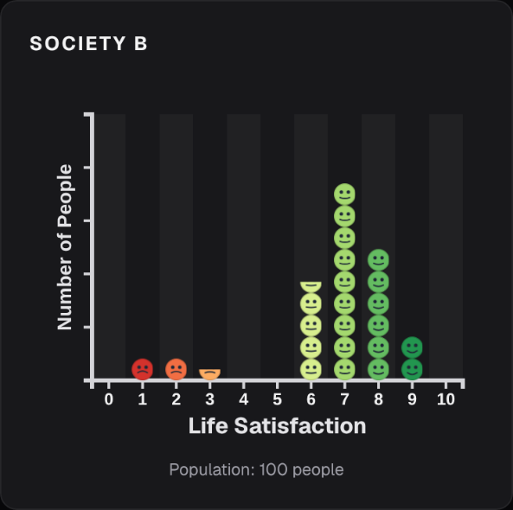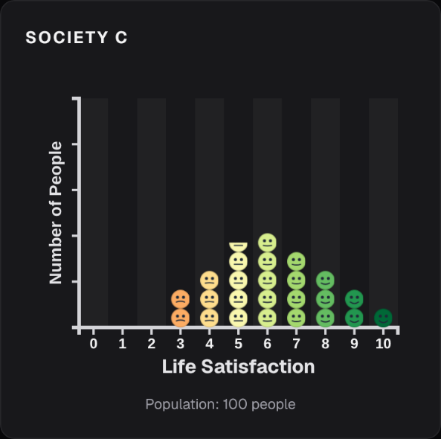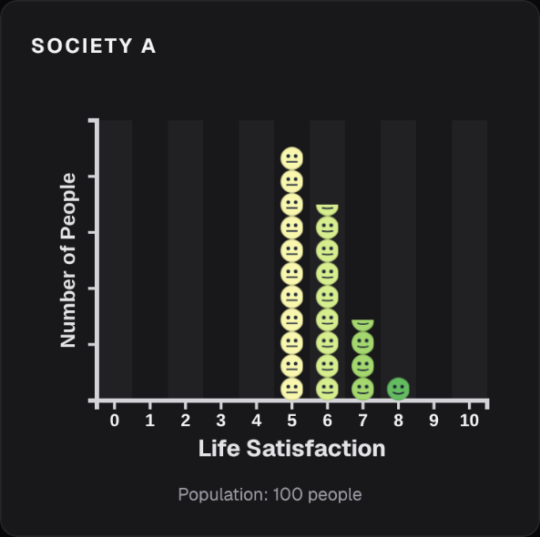

LO3
3.1 Select the correct definition of utility:
(a) How happy someone says they feel on a given day
(b) The value of a 1-point gain in life satisfaction, which depends on where the person starts
(c) The difference between a decision made for yourself and one made for someone else
(d) The total life satisfaction
3.2 Each scoring system shows how many points a government earns for raising one person by 1 point, depending on where they start. You can assume there are always some people in the 2-3 bracket.
Step | System X | System Y | System Z
2-3 | 100 | 100 | 100
4-5 | 100 | 0 | 60
6-7 | 100 | 0 | 30
8-9 | 100 | 0 | 10
Which system is (a) Benthamite, (b) Rawlsian, (c) somewhere in between?
3.3 Where do utility values come from?
(a) National GDP and economic growth figures
(b) The choices people make between hypothetical gambles
(c) How many people are at each life satisfaction level
(d) How happy people say they feel today

LO4
4.1a Imagine you don’t know which of the 10 people in a society you’d be, and you’re asked in which society you’d rather exist. What is this way of reasoning called?
(a) The veil of ignorance
(b) Diminishing marginal utility
(c) Benthamite ethics
(d) Risk aversion
4.1b Which statement describes personal utility, and which describes social utility?
(a) How much you value gains for others, based on the risks you would take yourself?
(b) How much you value a gain in your own life, based on hypothetical choices you’d make as if in charge of others
(c) How much you value gains for others, based on having to make hypothetical choices that affect others
(d) How much you value a gain in your own life, based on hypothetical choices about your own life
4.2 Complete the sentence: People’s choices about their own life tend to be [___] than the choices they make on behalf of others.
(a) Safer/more risk-averse
(b) About the same
(c) Riskier/more risk-tolerant
4.3 Which statement best describes the dilemma for government?
(a) Social utility gives more weight to the worst-off than personal utility does, so the two can recommend different policies
(b) Personal and social utility always recommend the same policy, so the choice doesn't matter
(c) Personal utility gives more weight to the worst-off than social utility does
(d) The dilemma is only about what a policy costs, not who gains from it
4.4 The table below shows two policies, and how much each person’s 1-point gain is worth under personal and social utility
Policy | People | Step | Personal value per person | Social value per person
A | 5 | 6→7 | 60 | 10
B | 1 | 2→3 | 100 | 100
Policy A raises 5 people by 1 point, from 6 to 7. Policy B raises 1 person by 1 point, from 2 to 3.
(a) Which policy does personal utility favour?
(b) Which policy does social utility favour?
(c) Why do they diverge?
4.5 Match each argument to the approach it supports (personal utility/social utility/neither):
(a) It respects the choices people make for their own lives
(b) It reflects what people endorse when they’re responsible for others
(c) It always maximises total life satisfaction, whoever gains

Outcome Measures
OM1 - How should government decide: (a) by the risk and reward people would choose for themselves, (b) by the risk and reward people would choose for others, (c) something in between, or (d) another way (e.g. Benthamite, Rawlsian, or other)? Explain.
OM2 - Are there policy domains where decisions shouldn't weigh or trade off life satisfaction at all? If so, which, and why? Examples: NHS funding, education, civil rights, national defence spending, welfare and public health spending, environmental policy?
(Exploratory, not scored)

Non-LO Questions for Game Group

Pre-Test
Gaming Frequency:
- "How often do you play video games?"
(e.g. never / rarely / monthly / weekly / daily)
Gaming Experience:
- “What type of games do you play?”

Post-Test
Agency and Control:
- “I felt in control of my learning experience.”
- “I felt that my decisions had a meaningful impact on the outcomes in the game.”
Enjoyment and Engagement:
- “I found the learning material to be enjoyable.”
- “I would play a game like this in my own free time.”
- “The game held my attention better than a more traditional method of education would have.”
Serious Experience:
- “The game made me think critically about how policies affect different groups in society.”
- “The scenarios presented in the game felt relevant to real-world issues.”
- “I found the experience thought-provoking, even if it was not always ‘fun’.”
Usability and Clarity:
- “The game’s rules and feedback were clear and easy to understand.”
- "I did not feel overwhelmed by the amount of information presented on screen at one time."

